Clearinghouse Mechanism for Adaptation

Contract nr: Nº 070307/2010/569200/SER/C3

Development of the Climate Change Impacts Vulnerability and Adaptation Clearinghouse
Implementation Phase 3

Maintenance Workflow Guide

Version 1.0
March 7, 2012
Wageningen, the Netherlands



Alterra
Wageningen University and Research;
Droevendaalsesteeg 3, 6708 PB
Wageningen, The Netherlands

In cooperation with


Version history

Version | Date | Description
1.0 | 07/03/2012 | Final

Table of contents

1 User roles and permissions 2
1.1 Web content 2
1.2 Database items 2
2 Workflows 3
2.1 Web content 3
2.2 Database items 4

User roles and permissions

Web content

Role: Writer
Users that can edit existing web content (e.g. EEA, ETCs)
- Edit web content
- Submit content for publication

Role: Portal Content Reviewer
- Review and reject or publish submitted web content

Database items

Role: User
Users that can (when logged in) access the functions to submit a new database item (all users of Climate-ADAPT who have requested a EIONET username and passwords)
- Share information, submit new database items

Role: Power User
Users that can add and edit CLIMATE-ADAPT database items (e.g. EEA, ETCs)
- Add/edit CLIMATE-ADAPT database items (create candidate item for approval by administrator)

Role: Administrator
- Review and reject or publish CLIMATE-ADAPT database items

Workflows

Web content

Workflow of content management is implemented via the 1-step approver mechanism (provided by Liferay), as depicted in Figure 1.
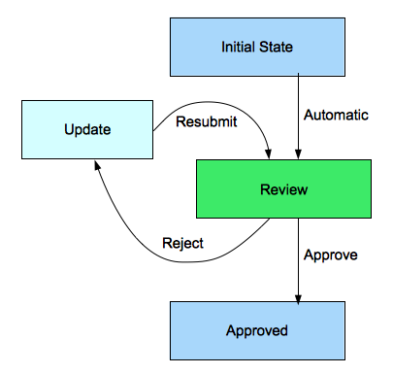
Figure 1 – Workflow for CLIMATE-ADAPT web content maintenance

- User with the role writer can update web content (steps: initial state, update) and submit for publication (transitions: initial state → review, update → review)
- Users with role portal content reviewer get a mail if content is submitted for review and have access to the submission queue (steps: review)
- Users with role portal content reviewer can assign a submitted change in the submission queue to their selves (step: review)
- Users with role portal content reviewer can comment and/or edit submitted changes (step: review)
- Users with role portal content reviewer can reject submitted changes (transition: review → update)
- Users with role portal content reviewer can approve (and in that way publish) submitted changes (transition: review → approved)
- Users with the role writer can view the submission progress

Database items

NB: Note that database items are processed in a different way, since they are not Liferay web content. They are managed through the workflow depicted in Figure 2.
Newly created items start their lives as (unapproved) candidate items. Candidate database items are not visible to users until they are approved. Upon review and approval the item becomes an approved item and becomes visible for end users. When an existing item is edited, a copy candidate item is created. This copy goes through the review/approval process and when approved, the item becomes an approved item, and replaces the former database item.
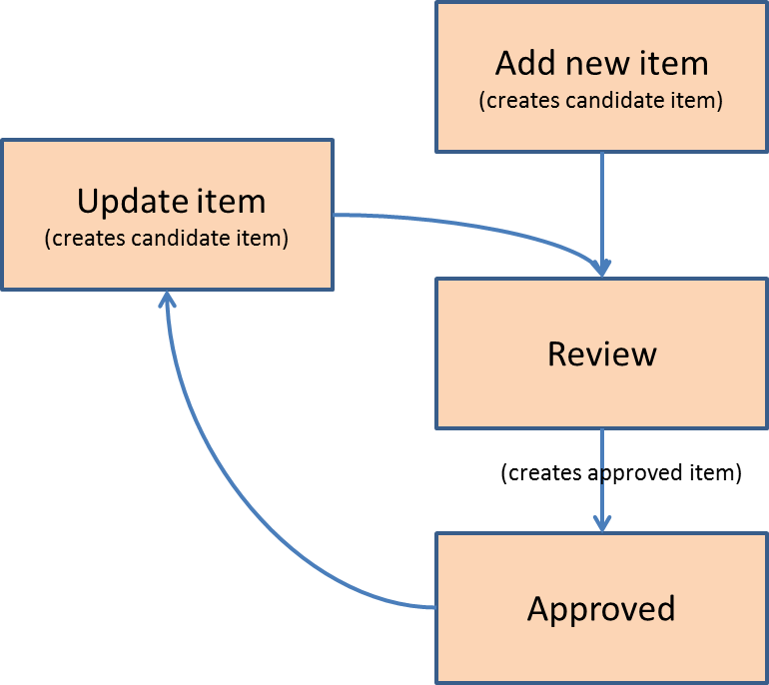

Figure 2 – Workflow for CLIMATE-ADAPT database item maintenance

- Public (non-authenticated) CLIMATE-ADAPT users can access “share your info” page content and access a link that allows them to log in (with the role user).
- Logged in users with role user can access the “share your info” page and access a link to upload information. An on-line template can be filled in and submitted, which creates a (new) candidate item to be approved in the review process
- Users with the role power user can add/maintain candidate CLIMATE-ADAPT database items (maintain menu). Power Users can edit earlier approved items; The proposed changes then become a candidate item. Meanwhile the existing database item stays visible to users until the candidate item is approved. Also the existing database item gets locked; it cannot be edited or deleted until the candidate item is approved or deleted.
- Administrators can approve new and edited CLIMATE-ADAPT database items
- Power Users can delete candidate items; they cannot delete approved items.
- Administrators can delete all database items (candidate and approved).

